Create Google Sheets with name “IoT Based RFID Attendance System”.

In Extension Tab Click on App Script >> And Paste the code from the the File "Google App Script"



Keep name of app script same as the google sheet name.

In the 8th Line ‘var sheet_id' Paste Your sheet id “1Kv5MezWhWanOqYyCKgSoWR-2j5tlO43WbxXsO-p4urA"

Once code is pasted click on the Deploy>New Deployment> Write Description and click on deployment and select your google account.

Copy Web URL and Save it somewhere.

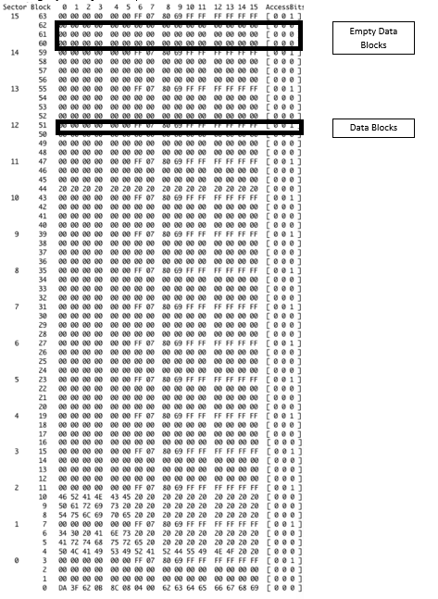

Once google sheet part is done

Install the Libraries from library Folder

Come back to “Write Data on RFID” code and update the code according to your Requirements

Enter the data only in Empty Blocks and accordingly.

Once Data is Feed in to RFID

Upload other Code Named “Final Code To RFID” and Upload To ESP8266

Before uploading update the following data

1. URL of App Script
2. WIFI SSID
3. WIFI Password
4. Enter Fingerprint Certificate of the Website

To get certificate follow these steps

1. A picture containing text, font, screenshot, logo

   Description automatically generated
2. A screenshot of a computer

   Description automatically generated with low confidence
3. A screenshot of a computer

   Description automatically generated with medium confidence
4. 
5. Enter these SHA-1 Fingerprint.

Once Done Upload the Code

Circuit Diagram for the Code

